Regional Emergency Medical
& Trauma Services
Systems Development Biennial Plan

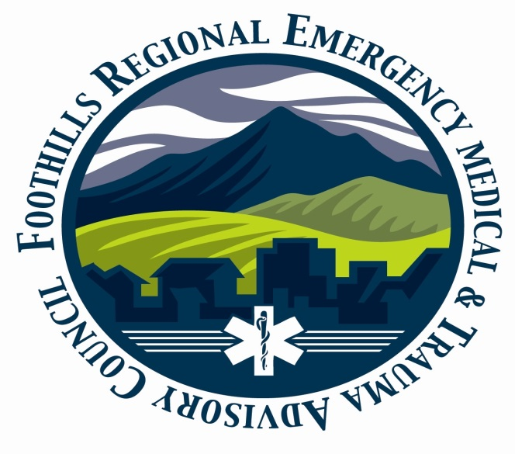

Foothills RETAC
Plan Cycle
July 1, 2020 – June 30, 2021

Plan: | Original for Plan Cycle
Date Submitted: | 6-30-2019
Contact Person: | Linda Underbrink
Address: | 8161 W Eastman Place #204 Lakewood, CO 80227
Phone: | 303-594-9740

Table of Contents

Section 1: ………………………………………………………………………………………… 3

RETAC Overview: …………………………………………………………………… 3
Mission Statement: ……………………………………………………… 4
Description: …………………………………………………………………. 6
Ongoing Organization and Planning Process: ………………. 17

Section 2: ………………………………………………………………………………………… 21

Accomplishments: …………………………………………………………………. 22

Section 3: ………………………………………………………………………………………… 36

EMTS System Components: …………………………………………………… 37

Section 4: ………………………………………………………………………………………… 40

Goals and Objectives: ……………………………………………………………. 41

Section 5: ………………………………………………………………………………………… 47

Attest Statement: …………………………………………………………………… 48

Appendices: ……………………………………………………………………………………. 49

Supporting Documents for Foothills RETAC (Appendices)

A. Foothills RETAC Board Members: …………………………… 51
B. EMS Transporting Agencies: …………………………………… 53
C. Trauma Centers: ……………………………………………………… 55
D. Fire Agencies: …………………………………………………………. 56
E. Search and Technical Rescue: ………………………………… 58

Section 1: RETAC Overview:

Mission Statement:

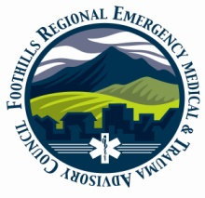 Foothills Regional Emergency & Trauma Advisory Council
(FRETAC)
Serving Boulder, Clear Creek, Gilpin, Grand, & Jefferson Counties

Mission Statement

To create, enhance, and promote a systematic approach to the
Care of the critically ill or injured through Quality Improvement,
Injury Prevention, Disaster Planning and coordination of
Partners in the healthcare continuum

Description:

RETAC Description: Map of Foothills RETAC

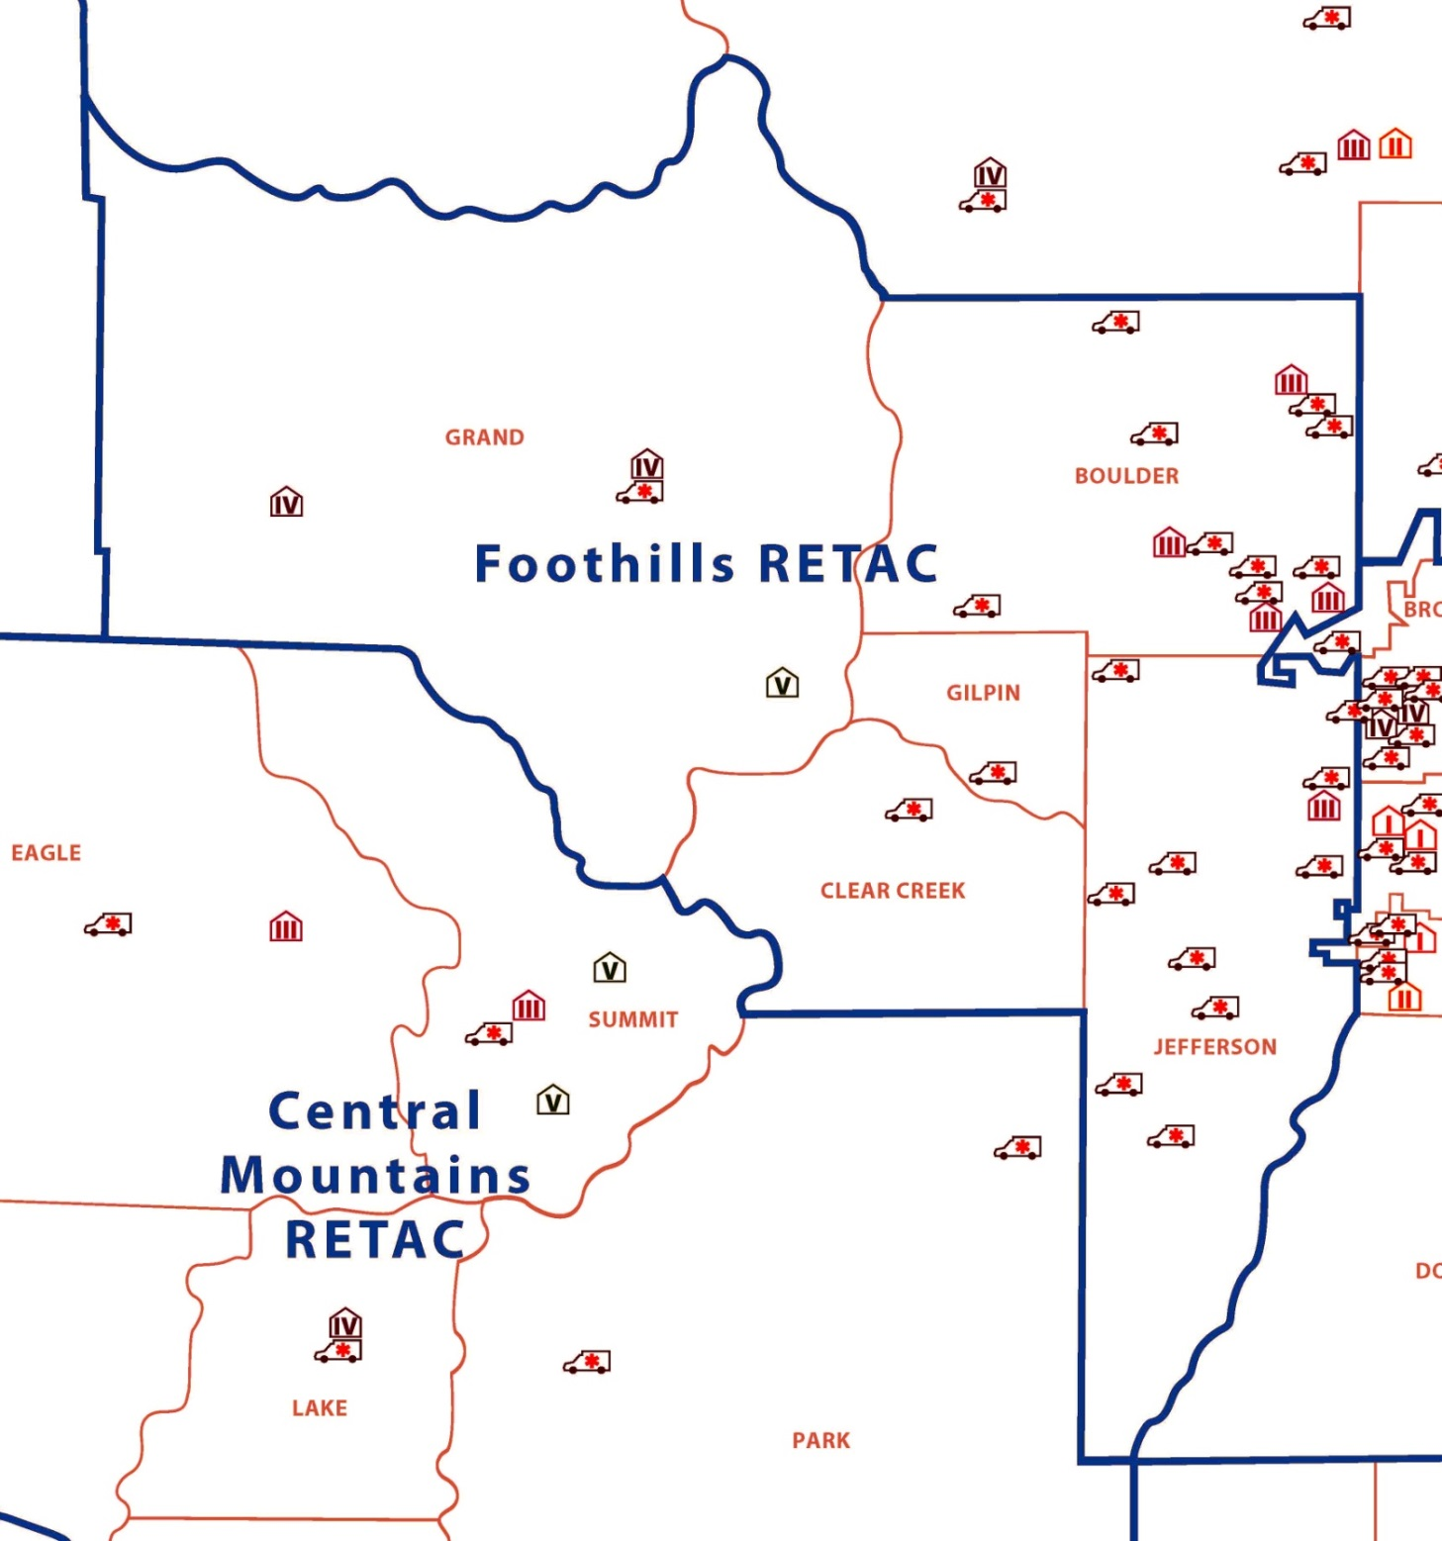

RETAC Description Narrative:

- Foothills RETAC Participating counties

  - Boulder
  - Clear Creek
  - Gilpin
  - Grand
  - Jefferson

- RETAC Population Breakdowns
2018 Estimated Total Population
County | Estimated Population in 2018 | Population in 2010 | Percentage of Increase/Decrease
Boulder | 326,078 | 294,567 | 10.7%
Clear Creek | 9,605 | 9,088 | 6%
Gilpin | 6,121 | 5,441 | 12.3%
Grand | 15,525 | 14,843 | 4.6%
Jefferson | 580,233 | 534,543 | 8.5%
Total RETAC
Population | 934,562 | 858,482
Colorado Est Pop. | 5,695,564 |  | 17% of CO Population

Persons per Square Mile: 2018
Boulder | 405.6
Clear Creek | 23.0
Gilpin | 36.3
Grand | 8.0
Jefferson | 699.5
Colorado | 48.5
- Population Density and Urban Centers by Selected Cities and Towns in 2010
Boulder | 2018 Population
Boulder | 107,353
Evans | 21,236
Lafayette | 28,924
Longmont | 96,577
Louisville | 21,165
Windsor | 28,967
Clear Creek | 2010
Georgetown | 1,034
Idaho Springs | 1,717
Silver Plume | 170
Empire | 276
Gilpin | 2010
Black Hawk | 118
Central City | 663
Grand | 2010
Fraser | 1,224
Granby | 1,864
Grand Lake | 471
Hot Sulphur Springs | 663
Kremmling | 1,444
Winter Park | 999
Jefferson | 2010
Arvada | 106,433
Golden | 18,867
Lakewood | 142,980
Wheat Ridge | 30,166

- Other Demographics-2018

Household Median Income | 2018 | % in Poverty
Boulder | $75,669 | 12.6%
Clear Creek | $68,534 | 7.8%
Gilpin | $72,544 | 6.9%
Grand | $66,489 | 8.7%
Jefferson | $75,170 | 7.6%
It is important to note that in Clear Creek, Gilpin, and Grand Counties these numbers may be skewed because of pockets of multi-millionaires that live there.
Colorado Average | $65,458 | 10.3%

Median value of owner-occupied housing units | 2011-2015 | 2018
Boulder | $368,800 | 423,500
Clear Creek | $283,900 | 317,000
Gilpin | $252,800 | 301,700
Grand | $282,000 | 285,000
Jefferson | $279,500 | 334,100
Colorado Average |  | $286,100

- County Governments

Boulder | Clear Creek
Boulder County | Clear Creek County
 | 405 Argentine Street
1325 Pearl St | P.O. Box 2000
Boulder, CO 80302 | Georgetown, CO 80444-2000
Phone: 303.441.3500 | Phone: 303.679.2312
Fax: 303.441.4525 | Fax: 303. 679.2440
County Profile | County Profile
Location: North Central Colorado | Location: West of Denver
Size: 740 square miles | Size: 397 square miles
Population 2018: 326,078 | Population 2018: 9,605
Courthouse Open: 8 a.m. - 4:30 p.m. | Courthouse Open: 8 a.m. - 4:30 p.m.
Commissioner meetings: Monday-Friday | Commissioner meetings: 1st & 3rd Tuesdays
Congressional District: 2, 4 | Congressional District:2
Senate Districts: 16, 17, 18, 23 | Senate District: 16
House Districts: 10, 11, 12, 13, 33 | House District: 13
CCI District: Front Range | CCI District: Mountain

Gilpin County | Grand County | Jefferson
Gilpin County | Grand County | Jefferson County
203 Eureka St | 308 Byers Ave. | Jefferson County Government Services
P.O. Box 366 | P.O. Box 264 | 100 Jefferson County Parkway
Central City, CO 80427-0366 | Hot Sulphur Springs, CO 80451-0264 | Golden, CO 80419-5550
Phone: 303.582.5214 | Phone: 970.725.3347 | Phone: 303.271.8525
Fax: 303.582.5440 | Fax: 970.725.0565 | Fax: 303.271.8941
County Profile | County Profile | County Profile
Location: North Central Colorado | Location: North Central Mountains | Location: West of Denver
Size: 150 square miles | Size: 1,869 square miles | Size: 773 square miles
Population 2018: 6,121 | Population 2018: 15,525 | Population 2018: 580,233
Courthouse Open: 8 a.m.- 5 p.m. | Courthouse Open: 8:30 a.m. - 5:00 p.m. | Courthouse Open: 8 a.m. - 4:30 p.m.
Commissioner meetings: Tuesdays | Commissioner meetings: Tuesdays | Commissioner meetings: Varies-See schedule
Congressional District: 2 | Congressional District: 2 | Congressional District: 7
Senate District: 16 | Senate District: 16 | Senate District: 16,19,20,21,22,26,32
House Districts: 13 | House District: 57 | House District:1,22,23,24,25,26,27,28,29,38
CCI District: Mountain | CCI District: Mountain | CCI District: Front Range

- Overall RETAC Statistics/Overview

Foothills RETAC Totals
Total Square Miles:
Approx. 4,000 Sq. miles
Congressional Districts:
7, 2, and 4
Senate Districts
16,19,20,21,22,26,32, 17, 18, 23
House Districts:
1,22,23,24,25,26,27,28,29,38, 57, 13, 10,
11, 12, 13, 33
Estimated Population 2018: Approx. 934,562

- Major transportation routes

County | Transportation Routes
Boulder | - Highway 36 from downtown Denver  - Highway 93 from Golden  - Highway 119 from Highway 93 to Nederland  - Highway 7 to Lyons  - Highway 119 or Highway 237 to Longmont  - Urban, Suburban, and Rural
Clear Creek | - I:70 from Western Metro area  - Guanella Pass  - Squaw Pass  - Eisenhower Tunnel  - Highway 6 from Golden  - Central City Parkway  - Loveland Pass: US 6  - Rural and Frontier  - US 40 to Berthoud Pass
Gilpin | - Highway 119 from highway 6 through Black Hawk over Nederland and down to Highway 93  - Central City Parkway  - Rural and Frontier
Grand | - Highway 40 from I:70 through Grand County over Berthoud pass to Rabbit Ears Pass to Steamboat  - Highway 9 from Silverthorne to Kremmling  - Rural and Frontier
Jefferson | - I:70, Highway 285 and US 40  - Highway 6 (6th Ave)  - Simms  - Kipling  - Wadsworth  - Sheridan  - Urban, Suburban, and Rural

- Major economic activities (i.e. agriculture, tourism etc.)

County | Economic Activities
Boulder | - Professionals  - Tourism  - Education  - Wholesale  - Retail  - Manufacturing  - Healthcare  - Agriculture
Clear Creek | - Mining  - Tourism  - Commuting  - Wholesale  - Retail  - Manufacturing
Gilpin | - Accommodations  - Food Service  - Tourism  - Gambling
Grand | - Retail  - Accommodations  - Wholesale  - Tourism  - Agriculture
Jefferson | - Manufacturing  - Retail  - Building  - Wholesale

- Number of emergency communications centers
County | PSAPS
Boulder | 3
Clear Creek | 1
Gilpin | 2
Grand | 1
Jefferson | 3
RETAC Total | 10

- Number of ground ambulance providers

County | Ground Ambulance Providers
Boulder | 8
Clear Creek | 1
Gilpin | 1
Grand | 1
Jefferson | 15
RETAC Total | 26

- Number of air ambulance providers

County | Air Ambulance providers
Boulder | 1 chopper staged
Clear Creek | 0
Gilpin | 0
Grand | 0
Jefferson | 1
RETAC Total | 1
- Number of acute care (non-trauma center) and critical access hospitals

County | Non-Trauma Center Facilities
Boulder | 2
Clear Creek | 0
Gilpin | 0
Grand | 0
Jefferson | 5 & multiple Free standing EDs
RETAC Total | 7+

- Number and levels of designated trauma centers

County | Designated Trauma Centers  and Levels
Boulder | 5 Total  (2) Level IIs and (3) Level IIIs
Clear Creek | 0
Gilpin | 0
Grand | 3  (2) Level IVs and (1) Level V
Jefferson | 2  (1) Level III and (1) Level I
RETAC Total | 10

- Major EMTS patient destinations outside of your region

County | Destinations Outside RETAC
Boulder | - North Colorado Medical Center  - St Anthony’s North  - High Level Trauma Centers in the Denver Metro Area
Clear Creek | - Denver Metro Area, Summit County (West)
Gilpin | - Denver Metro Area
Grand | - Denver Metro Area  - Summit Medical Center  - Yampa Valley Medical Center
Jefferson | - Denver Metro Area

Ongoing Organization and Planning Process:

Organization:

- Basic structure and function of the Foothills RETAC organization.
- Legal structure of the RETAC (i.e. non-profit corporation)
    - IRS 115 Government Instrumentatlity Non-Profit

- Membership of the RETAC council by position (See Appendix A)
- Distribution of the council members among participating counties:
(See Appendix A)

- Frequency of RETAC meetings
  - Full Board Meetings held on the 3rd Wednesdays of the month every other month
  - Committee meetings held 3rd Wednesday of the month every month and as needed for each committee’s activities

- How the RETAC utilizes contracted services

  - Contracted Services are utilized per project need. We currently have:
    - RMD/EMS Coordinator
    - An Admin. Asst. to perform meeting minutes and board packets
    - A Contractor specific to our IP Provider Grant
    - A Contractor specific for our MCI TTX project

- RETAC staff member(s) and staff role descriptions

  - One staff member hired by the RETAC
    - RETAC Executive Director/Exempt Employee Status

- Committees of the RETAC council

  - The RETAC currently has 4 “Standing Committees”
    - Executive/Finance Committee
    - MCI Committee
    - Clinical Care Committee
    - Injury Prevention

  - Ad-Hoc Committees currently active include:
    - Grants Committee

- Integration with county councils

  - There are currently no county-wide “official” EMS Committees within our RETAC
  - The Boulder County Firefighters do have an EMS Committee

- Significant region-wide challenges

- Region-wide challenges include many of the issues listed above such as long transport times, no trauma centers in Gilpin and Clear Creek Counties, and no high-level centers in 3 of the 5 more rural counties.

- The diversity within the region also presents challenges. The geography, population densities (or lack thereof) in certain parts of the region and the lack of partnerships or coalitions outside the RETAC board are all challenges.

- County Description of significant barriers to patient care

County | Barriers to Patient Care
Boulder | Boulder County is fortunate to have 3 Level III Trauma Centers and 2 Level II Trauma Centers with 9 Licensed Ground Ambulance services, BUT, at least 4 of the ambulance services transport routinely on a rendezvous basis only. Those services are in rural Boulder and they rendezvous with AMR, who has the contract for the City of Boulder at present.  The rural parts of Boulder are constantly working to decrease rendezvous and transport times with AMR. It is a large challenge for the mountainous regions of Boulder to keep EMS trained staff to answer calls and maintain skills.

Clear Creek | Clear Creek and Gilpin County have the same geographical and trauma center issues. Neither county has a receiving medical facility within their counties, or within over 30 miles. They each have one county ambulance service that must transport most patients into the Denver Metro area with some to Summit County through the tunnel, but this means that their average transport times to GET to the facility is over 30 minutes, and many times more. Their protocols must be slightly different to adapt to this situation. Evergreen Fire does cover the SE corner of Clear Creek
Gilpin | Same as Clear Creek above, but with the addition of the numerous challenges managing the healthcare needs of a county that allows legal gambling. There are no healthcare facilities, and EMS must transport patients to the metro area. Many of these patients are elderly with a multitude of medical issues enjoying their day in the casinos.
Grand | Grand County is in a unique situation with 1,869 square miles to cover. They are one of the largest counties in the state with over half of the county marked as “frontier” with the rest being rural. They also have 2 ski areas with Winter Park and Sol Vista. They must station their ambulances around the county in a way that makes sense to cut down response times, and yet be fiscally responsible.  The other issue from Grand County is that they have 1 county ambulance service, with 2 Level IV trauma centers, and 1 Level V Center at Winter Park. Only one of those facilities is a hospital and will admit very few patients, and certainly no trauma patients. Therefore, over half of Grand County EMS transports are inter-facility into the Denver Metro area, or occasionally to Yampa Valley. This takes ambulances out of county for more than 3 hours at a time. Again, the economics are intense to cover these.
Jefferson | Jefferson County is mainly a suburban area. They are lucky to have numerous transporting agencies. They currently have two designated Trauma Centers and multiple non-designated Centers and free-standing Eds. One issue that affects care in Jefferson is the I:70 corridor up through to Clear Creek. This stretch of highway is the deadliest in Colorado and encompasses Evergreen (no trauma center) and Highland Rescue at Dead Man’s curve.

- Ongoing process used to assess RETAC needs

- Assessment of EMTS needs within the RETAC is accomplished mainly through the RETAC membership and our committee membership. All EMTS stakeholders are members of these committees, and all of them have input into our strategic planning and goals. With such a diverse group of members, we feel like we have a good handle on the needs and challenges of the region. We have completed topic-specific surveys and have an active listserve of members to reach those in our RETAC.
- Assessment of the Biennial Plan Goals, Objectives, and Accomplishments are also used to assess needs and to analyze current priorities and activities. This is done yearly as we asses our accomplishments and list our goals for the coming year.

- Process used to develop Biennial Plan

- The process for this year’s Biennial Plan began in April. Each RETAC Committee scheduled a strategic planning session to assess current Goals and Objectives. Those are compared to accomplishments to current goals versus the current needs. New goals and objectives for each committee will be developed in June for the upcoming two years.
- After this is completed, the draft Biennial Plan goes out via e-mail in June for final approval. Keep in mind that MOST of the board members are also committee members, so they have been intimately involved in the development of the new plan.

- Process used to communicate, implement, and measure
Biennial Plan goals

- To evaluate, implement, and communicate our goals and objectives, these will be referred to at committee meetings and a report will be given during our full board meetings for the year. At the end of the first year, a full evaluation will be done, and the goals and objectives will be revisited to ascertain their current applicability and map their progress.

Section 2: Accomplishments:

FY-18 Goal #1: Injury Prevention

A. Goal Statement

Injuries and deaths in the Foothills RETAC will be decreased throughout the Region through the establishment and utilization of effective cohesive IP programs and strategies.

- Background

The Foothills RETAC Injury Prevention Committee is actually a coalition of many IP organizations within the RETAC along with our IP members specifically. This goal has not changed for the Committee and the RETAC. They see no better goal than what is already written. We will continue to try to reduce injuries and death within the RETAC through our proven programs and activities.

- Components Addressed

Injury Prevention, Information Systems, and Clinical Care

- Project Description

Objective 1: Build Injury Prevention Coalitions within the Foothills RETAC to address the major causes of injuries/deaths within our region.

Tasks:

- Collaborate and develop relationships with Public Health agencies, EMS, Private IP groups, and Healthcare facilities to prevent injuries within our region
- Research, identify and encourage additional partners to join FRETAC Injury Prevention Coalitions
- Analyze the Foothills RETAC Injury Prevention Project data and other data information to implement and perform evidence-based injury and illness prevention within the FRETAC.
- Research funding options/apply for grants and seek funding to address IP programs within the FRETAC.
- Continue relationship and collaboration with IP partners to focus on Occupant Safety.
- Coordinate with Fall Prevention partners to collaborate, implement, and evaluate Fall Prevention programs and strategies.
- Continue Administration of C-DOT grant.

Injury Prevention

FY-18: Accomplishments/Activities

1st Quarter

Injury Prevention Activities:
  - ThinkFirst Program: Many, many ThinkFirst classes were given during this quarter. Working with schools for that portion of the program.
  - Received word that our grant was approved. Will wait for signatures and when the grant is complete, we’ll get started.
Numerous Stepping on and Matter of Balance classes taught in the region
2nd Quarter

Injury Prevention Activities:
- Working with schools for that portion of the program.
- We are in full bore with this project with the grant we received from CDPHE for Older Adult Fall Prevention. We hired a great coordinator for the project, and she is eager and productive. We have already made a LOT of progress since our timeline for the project is so crunched with the delay in signing the contract. Working very hard to catch up. Have already put on one Matter of Balance Class and have 2 more Stepping On classes scheduled.
3rd Quarter

Injury Prevention Activities:
- ThinkFirst Program: Many, many ThinkFirst classes were given during this quarter. Working with schools for that portion of the program.
- We are in full bore with the Older Adult Fall Prevention project with the grant we received from CDPHE. We hired a great coordinator for the project, and she is eager and productive. We have completed one Stepping on class in Jeffco in conjunction with St Anthony. The last will be in Gilpin County and is for the more rural groups to attend.
- Our Coordinator for the Fall Prevention is industriously visiting with Fire and EMS groups to encourage home safety assessment. We are giving them the rug skids night lights to give to the elderly when they perform the assessments. The committee also approved a home safety assessment checklist for the agencies to use.

4th Quarter and Final Report on Activities and Accomplishments for the Year

Injury Prevention Activities:
- ThinkFirst Program: Many, many ThinkFirst classes were given during this quarter. Working with schools for that portion of the program.
- Older Adult Fall Prevention Program/Grant: We are in full bore with the Older Adult Fall Prevention project with the grant we received from CDPHE. We hired a great coordinator for the project, and she is eager and productive. We have completed one Stepping on class in Jeffco in conjunction with St Anthony and one Matter of Balance held in Boulder. The last was in Gilpin County and provided an opportunity for the more rural groups to attend.
- Our Coordinator for the Fall Prevention is industriously visiting with Fire and EMS groups to encourage home safety assessment. We are giving them the rug skids night lights to give to the elderly when they perform the home assessments. The committee also approved a home safety assessment checklist for the agencies to use. At last report, 17 agencies agreed to perform these assessments!

FY:18-19 Goal #2: Clinical Care

A. Goal Statement

Establish and maintain Foothills RETAC specific Projects and Regional QM Programs and develop processes for these programs

- Background: The Foothills RETAC Injury Prevention Committee is actually a coalition of many IP organizations within the RETAC along with our IP members specifically. This goal has not changed for the Committee and the RETAC. They see no better goal than what is already written. We will continue to try to reduce injuries and death within the RETAC through our proven programs and activities.

- Components Addressed: Evaluation, Information Systems, and Clinical Care

- Project Description
Objective 1: Evaluate and conduct a regional Quality Management (QM) project within the Foothills RETAC Clinical Care Committee

Tasks:

- Complete required Internal Review Board (IRB) applications for the Foothills RETAC participating hospitals for the elderly cervical spine immobilization quality management study.
- Hire a data consultant to assist in IRB document submittal and to develop the statistical analysis tools for use in the cervical spine immobilization study.
- Develop partnerships with participating hospitals and trauma registrars participating in the cervical spine immobilization project in the effort to yield consistent and usable data across hospitals and hospital systems.
- Evaluate the psychiatric advisory hour hospital status in the Foothills RETAC and identify best practices and areas of improvement where hospitals can minimize psychiatric advisory utilization.

Objective 2: Establish the flow of data between all partners involved in Foothills RETAC Quality Management

Tasks:

- Identify all partners involved in a RETAC QM Program. This may include:
  - Prehospital agency Medical Directors
  - Facility Medical Directors
  - Trauma Program Managers, Trauma Coordinators, and other facility partners
  - Prehospital EMS Agencies
  - CDPHE Data Program and CDPHE EMTS Section and Public Health
  - DMEMSMD Group
  - Other Physicians not involved in the DMEMSMD group
  - Regional Medical Liaisons
  - RETAC Coordinator
  - Office of Emergency Management
- Identify methods for collecting QM Data by working with the above
- Establish the process that will be used to collect/use data for QM
- Provide QM educational support to our RETAC partners as needed.

Objective 3: Maintain our Regional Medical Direction/Collaboration program with Mile-High RETAC

Tasks:

- Prehospital QM processes MAY differ from other RETAC QM processes. Identify the differences for this specific set of QM issues
- Work with the DMEMSMD group and other Medical Directors within the RETAC to address prehospital QM issues specifically in regard to structure, process, collection of data, flow of data, and membership as above.
- Assess methods for data collection and data submission to the state for the EMS agencies within the RETAC. Work to interface with the vendors, the agencies, and the state to address solutions of data quality.
- Develop Prehospital Cardiac Care QM Measures to assess Cardiac Care in the region as the data availability improves
Clinical Care

FY: 18-19 Accomplishments/Activities

1st Quarter

Clinical Care
  - The Committee has been researching possible topics for a new research project since our spinal immobilization study was so successful. It’s a lot of work, and the group is only discussing at this stage.
  - Numerous committee members are working on the CDPHE Chapter 2 and 4 Task forces. Will wait to work to make major changes to our algorithm.
  - Much discussion with the RMD group. Bill Clark meets with this committee every month to give us updates on the program and oversees the work. The new EMS Protocols were completed and sent out in July. Working with CDPHE on statewide benchmarking. A preliminary report was given to the committee on results this far. The numbers seem very low. Linda and Bill will look into the accuracy of the numbers.
  - Linda sent out the data compliance reports to our EMS agencies. Working with them individually to ascertain if there is a problem with submission and accuracy.
2nd Quarter

Clinical Care
  - The Committee has decided on a research project to undertake for the next year. We are talking about assessing flight versus ground transport efficacy. This is VERY preliminary, and we have not yet met with the sub-committee
  - Much discussion with the RMD group. Bill Clark meets with this committee every month to give us updates on the program and oversees the work. We are now making our way through the maze of developing a CARES registry for our two RETACs only. We decided to start with this because it may be quite a while before the rest of the state is on-board.
  - Linda and Bill sent out the data latest compliance reports to our EMS agencies. Working with them individually to ascertain if there is a problem with submission and accuracy.

3rd Quarter

Clinical Care
  - The Committee has met once a month to drill down on exactly what data points and issues we would like to study. We have 17 people on this research project, with Abbie Blackmore from St Anthony as lead.
  - Bill Clark continues to do an amazing job with the RMLs and the committee. He is a great liaison between the groups and keeps each group apprised of the activities of the other. He meets with this committee every month to give us updates on the program and oversees the work. We continue to work on starting our regional CARES program. Bill has organized many agencies so far and gotten commitments for them to come on board the registry.

4th Quarter and Final Report on Activities and Accomplishments

Clinical Care
  - Research Project: The Committee has met once a month to drill down on exactly what data points and issues we would like to study for our Air Vs Ground Transport study. We have 17 people on this research project, with Abbie Blackmore from St Anthony as lead. We are currently obtaining data from our facilities that will show us exactly how many transports we have from the SCENE via are and via ground transport. This will give us a good baseline to see if we have enough numbers just in our RETAC for this type of study.
  - RMD and CARES: Bill Clark continues to do an amazing job with the RMLs and the committee. He is a great liaison between the groups and keeps each group apprised of the activities of the other. He meets with this committee every month to give us updates on the program and oversees the work. Our next protocol update will be the first week of July. We continue to work on starting our regional CARES program. Bill has organized many agencies so far and gotten commitments for them to come on board the registry. An NDA was signed, and our portion of the program was funded.

FY:18-19 Goal #3: MCI

A. Goal Statement

Prehospital Providers and Healthcare Facilities will provide a standardized cohesive and efficient response to MCI events within the Foothills RETAC

B. Background:
The Foothills RETAC MCI Committee has changed our membership and focus for the last two years. We worked diligently for the last two years with Mile-High RETAC to integrate MCI systems. For the next two years, we will continue to do that as a side-effect to our new focus within our own borders.

C. Components Addressed
MCI, Education Systems, and Clinical Care

D. Project Description

Objective 1: Encourage and facilitate development of MCI Operational Plans by Fire/EMS agencies.

Tasks:
- Maintain a list of prehospital agencies and their members that have attended the MCICS course or its equivalent
- Resurvey prehospital agencies to ascertain status of individual operational EMS agency plans as compared to the original survey in 2009
- Collect current operational EMS agency plans
- Facilitate Operational MCI training
- Work with Medical Directors to accomplish the above
- Distribute the Foothills Regional RETAC MCI Plan and all related documents/education to prehospital agencies within the RETAC
- Visit regional stakeholders to encourage attendance at the Joint MCI Committee and obtain MCI/ MPI plans for EMS agencies and hospitals

Objective 2: Provide necessary tools that prehospital providers need to be effective and efficient in any MCI response

- Provide MCI Education as needed
- Provide outreach/education to all prehospital agencies to help them write an operational agency-specific MCI Plans
- Update and modify the FRETAC MCI Cache system as needed
- The RETAC MCI Committee will take an active role in the equipping and deployment of the MCI Trailers within the region to maintain the system.
- Continue to evaluate and update the RETAC MCI Plan
- Continue to evaluate and update all MCI-related regional documents

Objective 3: Facilitate a systematic integration to MCI management with our Healthcare Facilities and our prehospital systems

Tasks:
- Research Facility-specific MPI Plans
- Work with facility partners to identify differences in MCI Management to include, but not limited to:
  - Triage Categories
  - Bed-Counts versus Facility capabilities
  - Notifications/availability
  - Patient Tracking
- Train and utilize the Integration of EMSystems in all planning and exercises.
- Support education and use of 800 MHz radios for hospitals and EMS through daily use by EMS to the hospitals and monthly call downs

Objective 4: Improve Regional MCI Management and Response through education, exercise, and training and explore additional ways to improve MCI management integration

Tasks:
- Maintain relationships with neighboring counties and RETACs to facilitate integration of care
- Integration of information between the NCR, the Mile-High RETAC, and the Foothills RETAC will be shared
- Assist with exercises and training events such as hospital surge and evacuation
- Integration between Public Safety, emergency management, and medical facilities is essential in all planning
- Med-Surge and EMS Caches to be updated as per the minimum equipment list and to provide access documents, MOU’s and mission of caches to all stakeholders
- Review EMS capability assessment for potential gaps and need for funding
- Support efforts with EMSystems to provide a web page that would indicate ambulance availability during an MCI/ MPI event and to include regional education efforts regarding the use of EMSystems and the definitions used by hospitals and EMS
- Research the current process for priority deployment of medical resources
- Explore the feasibility of deploying MCI trailers outside of the region for the purpose of MCI/MPI management.
- Continue the development of the ‘Communications Surge Network’ to enhance communications resources to more effectively manage MCI/ MPI events within the State.

MCI

FY:18-19 Accomplishments/Activities

1st Quarter

MCI:

- The committee organized a survey to be put on Survey Monkey to see what our agencies would like/need for MCI preparedness. This was a two-month endeavor, and results of the survey were tabulated.
- Continue to plan for organization of 3 small MCI exercises within the region with one regional exercise when those are complete.

2nd Quarter

MCI:

- Using the results from our MCI survey, we put out requests for proposals for 3 tabletop exercises and on full scale exercise. More to come on that.

3rd Quarter

MCI:

- Using the results from our MCI survey, we put out requests for proposals for 3 tabletop exercises and on full scale exercise. More to come on that.
- The MCI Committee, with approval of the BODs contracted with “All Clear Emergency Management to run the TTXs. The first meeting (IPM) with All Clear and the agencies was held.
- Grand County will hold their tabletop tentatively on July 24th with a full-scale exercise tentatively scheduled for September
- The Boulder initial Planning meeting is scheduled for June.
- The Jeffco, Gilpin, Grand IPM is also scheduled for June.
- Lots of participation for this endeavor as a region and in their own areas.
- More to come on the TTXs
- Meeting in Vail regarding matching HCC boundaries with the RETAC boundaries. This is all VERY preliminary, and more meetings scheduled. Tom and Linda represented our RETAC at this meeting.

4th Quarter and Final Report on Activities and Accomplishments

MCI:

- The MCI Committee, with approval of the BODs contracted with “All Clear Emergency Management” to run the 3 area TTXs. The first meeting (IPM) with All Clear and the agencies was held.
- Grand County will hold their tabletop tentatively on July 24th with a full-scale exercise tentatively scheduled for September
- The Boulder initial Planning meeting is scheduled for June.
- The Jeffco, Gilpin, Grand IPM is also scheduled for June 19th.
- Lots of participation for this endeavor as a region and in their own areas.
- More to come on the TTXs
- Meeting in Vail regarding matching HCC boundaries with the RETAC boundaries. This is all VERY preliminary, and more meetings scheduled. Tom and Linda represented our RETAC at this meeting. Follow-up meeting scheduled for June 6th at the RETAC forum.

Section 3: EMTS Components:

FY:18-19 EMTS System Component Accomplishments and Activities:

Accomplishments and activities within other EMTS Components that are NOT listed specifically within the goals and objectives above

- Integration of Health Services

- The RETAC could not exist or function effectively without all our healthcare partners. It is imperative that we maintain close working relationships with others. Examples of this include:
  - Multi-Discipline integration is essential as we work with our facilities, EMS Agencies, All-hazards groups, Public Health, Emergency Management, CHA, Medical Directors, Mile-High RETAC, County governments, and other First Response agencies
  - These partners are all involved in one or more of our RETAC Committees
  - The RETAC Executive Director and Committee Chairs also attend many other regional meetings so that information is shared back and forth

- EMTS Research and System Quality Improvement

- The RETAC Clinical Care Committee completed our efforts in EMTS Research and our RMD program. We continue to pursue other research and QM projects over the next two years. See Clinical Care for specifics.

- Legislation and Regulation

- We continue to be involved in the latest efforts by CDPHE, the legislators, and other efforts to reform and codify the EMTS system. We have not been officially involved this year but stay abreast of the latest news, usually through EMSAC, RETAC forums, and board members.

- System Finance

- Mini-Grant Competitive Grant process is complete. We have funded all 4 of the 5 requests that were made through the process. Our process was completed June 21st. The total amount funded through the competitive process was $23,668.35. For our County Grant funding, 4 of our 5 counties were funded for a total of $20,000. Jefferson County again did not request their obligated funds. Last year, we were able to move the unused funds into our Special Projects fund, so that our agencies and stakeholders would still benefit from this program.
- The additional approximately $20,000 RETAC funding has continued to allow several of our committees to continue projects. Our “Special Projects” line-items include Injury Prevention, Clinical Care and Education, and MCI projects.
- The RETAC budget could only be balanced by adding funds in the additional funds granted to the RETAC this year. We are extremely thankful to be able to continue the great work in the region.

- Human Resources

- Our RETAC is very lucky to have Human Resource issues as a low priority. No activities for this year. Clear Creek, Gilpin, and Grand do have R&R programs.

- Education Systems

- Again, our RETAC is extremely lucky to have numerous mature and effective education programs. This includes our numerous Community Colleges, CU in Boulder, the smaller satellite colleges, and our private EMS educators such as St Anthony prehospital services, Pridemark education, AMR education, and the Boulder education groups. This year we were also able to fund a regional Handtevy System for those agencies that wanted to participate.
- Grand County has a very active education program within their EMS system as does Boulder County.

- Public Access

- No activities this year

- Evaluation

- SYSTEM evaluation is an overall theme in our RETAC. We are extremely pleased that all our Healthcare facilities participated in our Spinal Immobilization Project as described above. We are now drafting a new project to study the efficacy of air versus ground transport in the trauma patient.
- Evaluation continues to be an important component in our Regional Medical Collaboration project as described above

- Communications Systems

- The RETAC MCI Committee works hand-in-hand with numerous communication systems. This includes EMSystems and Dispatch Centers
- Much work has been done by some of our members working with NCR all-hazards to revamp the current EMS channels to standardize radio communications.

Medical Direction

See also Clinical Care above.

- Besides our RMD project listed in our goals above, the RETAC meets bi-annually with all our Medical Directors. This includes our facility Directors, Trauma directors, and of course our prehospital Medical Directors. We find this to be a good time to:
  - Inform them of our activities
  - Get their buy-in with activities
  - Find out their thoughts and opinions on what we should address
  - Integrate them into our systems

- Clinical Care
- This component is well documented above under Goals and Objectives

- Mass Casualty

- This component is well documented above under Goals and Objectives
.
- Public Education

- No activity within this component as a RETAC although many of our members are involved in their communities

- Prevention

- This component is well documented above under Goals and Objectives

- Information Systems

- The Clinical Care Committee, the RMD program, RETAC Executive Director, and the Regional EMS Coordinator are working diligently on this component
  - Numerous meetings with Docs, CDPHE, and others to try and solve the difficult problem with data and its usefulness.
- The MCI Committee also works on this component regarding EMSystems and Resources

Section 4: Goals and Objectives for FY-20 and FY-21

Injury Prevention

Foothills RETAC Goal #1 FY 20-21

Goal Statement

Injuries and deaths in the Foothills RETAC will be decreased throughout the Region through the establishment and utilization of effective cohesive IP programs and strategies.

Background

The FRETAC Injury Prevention (IP) Committee is a coalition of our IP Committee members, FRETAC facility representatives, FRETAC agency representatives and various IP organizations offering supportive agendas. The IP Committee goal stated above has been the foundation and motivation of this well-established, active committee for many years.

The inception of the FRETAC ThinkFirst Chapter in 2012 makes this an important addition to the FRETAC IP Committee and supports the goal of reduction in injuries and deaths in our region. Many FRETAC IP activities include ThinkFirst materials and curricula.

As a Committee, we are collectively dedicated to educating the public through the utilization of our proven programs and activities, with the result of a reduction in injuries and deaths within the counties served by FRETAC.

Components Addressed

Injury Prevention, Information Systems, Public Education, and Integration of Health Services.

Project Description

Objective 1: General Objective
All FRETAC IP Committee members and stakeholders will work together in the spirit of collaboration with the common goal of reducing injury and death in our region.

Support Other Injury Prevention and collaborate with IP initiatives within our communities.
Tasks:
- Work collaboratively with other injury prevention groups with the common goal of decreasing injury and death within the FRETAC region.
- Continue to grow, develop and optimize utilization of the FRETAC ThinkFirst Chapter. Track all ThinkFirst related activities continuously and report to the national ThinkFirst Foundation headquarters annually.
- Continue to educate IP Committee members on ThinkFirst curricula and updates.
- Work together continuously with all stakeholders to formulate and review an optimal plan for FRETAC IP activities and programs utilizing current data.
- Continue to track IP Committee activity.

Objective 2: Older Adult Fall Prevention
Using the data provided within last year’s older Adult Fall Prevention project/grant, analyze the success of the program and identify gaps to be addressed

Tasks:
- Gather current injury data from our Older Adult Fall prevention project to assess causes and types of injury and death related to falls before evaluating needs and determining optimal IP Committee fiscal year activities in Fall Prevention
- Analyze regional injury pre and post-program data to aid in implementing, performing and promoting other types of evidence-based injury and illness prevention programs and activities within the FRETAC.
- Track the success of the IP Committee-wide falls prevention campaign based on volume of falls prevention programs delivered and collaborative efforts within the IP committee.

Clinical Care

Foothills RETAC Goal #2 FY-20-21

Goal Statement

Establish and maintain Foothills RETAC specific Projects and Regional QM Programs and develop processes for these programs

Background:

The Foothills RETAC Clinical Care Committee is a dedicated group of individuals representing all disciplines within an EMTS system. They represent healthcare facilities, prehospital agencies, public health, and counties. They are committed to improving patient care through evidence-based medicine.

Components Addressed:

Evaluation, Information Systems, and Clinical Care

Project Description:

Objective 1:
Evaluate and conduct a new regional Quality Management (QM) project within the Foothills RETAC Clinical Care Committee

Tasks:
- Analyze the trauma population for other suitable projects to pursue.
- Identify opportunities and barriers to reaching trauma data.
- Using evidence-based data, problems identified, and member input, we will pursue other areas for possible research

Objective 2:
Maintain our Regional Medical Direction/Collaboration program with Mile-High RETAC
Tasks:
- Work with the DMEMSMD, Grand County Medical Directors, and the Boulder Physician Medical Directors group and other Medical Directors within the RETAC to address prehospital QM issues specifically regarding structure, process, collection of data, flow of data, and membership as above.
- Assess methods for data collection and data submission to the state for the EMS agencies within the RETAC. Work to interface with all stakeholders, the agencies, and the state to address solutions of data quality.
- Develop Prehospital QM Measures in the RMD system to assess data.

Objective 3:
Continue to support the state and regional efforts in the CARES program

Tasks

- Continue our support of the CARES program within our region
  - Gather data regarding the number of facilities now participating and others pursuing input into the CARES registry and support inclusion of facilities
  - Encourage participation by prehospital agencies in the program

MCI

Foothills RETAC Goal #3 FY-20-21

Goal Statement

As a collaborative effort of the stakeholders in MCI management within the Foothills Region, the MCI Committee endeavors to provide a conduit for communication, education, and planning to increase operational capability.

Background:

The Foothills RETAC MCI Committee has set its sights on developing a robust value proposition that better addresses the needs of agencies that fall within its jurisdiction. With an overarching goal of elevating regional MCI care and management we intend to lead the State as an exemplarily point of MCI expertise. With the loss of Bob Marlin, our long-time leader, we have begun to assess every aspect of our current strategy.

Components Addressed

Mass Casualty, education, System Evaluation.

Project Description

Objective 1:
Facilitate MCI Readiness
Tasks:
- Formulate an educational regional MCI system that can be utilized to encourage individual agency readiness
- Illustrate value of MCI preparedness
- Examine current and best practices in MCI oversight and management. Communicate best practices for MCI management in our region
- Outline practical path to become more MCI aware and prepared
- Take into account the range of exposure of different audiences
- Package above in a practical way to communicate to the regional stakeholders.

Objective 2:
Establish Lines of Communication with Regional Agencies
Tasks:
- Divide the region geographically and assign agencies to committee members within their region
- Illustrate value of being an MCI minded agency
- Aggregate data related to gaps in regional capability to drive educational offerings

Objective 3:
Update Developed Consumable MCI Curriculums
Tasks:
- Using results from agency assessments, develop curriculums that address common gaps
- Curriculum should be segmented by agency size and location/access to resources (e.g. rural v. suburban, large v. medium v. small/volley)
- Classes should be prepackaged and available for anyone to disseminate
- In addition to being driven by the gap analysis, classes should prepare agencies to participate in a preconceived exercise
- Initial, broad strokes, concept of exercise

Objective 4:
Continue efforts in Designing and Executing Regional Exercise(s)
Tasks:
- Encourage agency participation in the RETAC MCI Committee activities
- Assess ways of communicating specific agency MCI activities to the region to promote inter-agency cooperation and integration

Summary:
These projects set out to accomplish a few macro goals:
- Understanding the current state of MCI preparation, at a granular level
- Developing a grassroots communication with agencies within our jurisdiction, with the purposes of illustrating the value of MCI preparation and how the MCI committee can provide a path to greater capability.
- Teaching and testing basic principles, using the data collected to drive the development of more tailored programs.

We believe that, although all steps must be considered during the next two years, focusing effort on each sequentially will allow for maximum benefit. An important aspect of this process is to remain flexible to more pressing needs as they arise, through the process of evaluation and communication. This should be a living document that reflects any pivots that need to be made through the next two years.

Section 5: Attestation:

Section 5: Attest Statement

ATTEST STATEMENT

Biennial Plan Update

By signing below, the RETAC Chairman and the RETAC Coordinator attest that the information contained in this document, to the best of their knowledge, completely and accurately represents the most current information available to complete the RETAC Biennial plan. The goals and objectives incorporated herein have been reviewed and agreed upon by the RETAC Board of Directors to be included in this document.

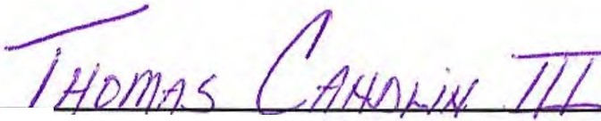

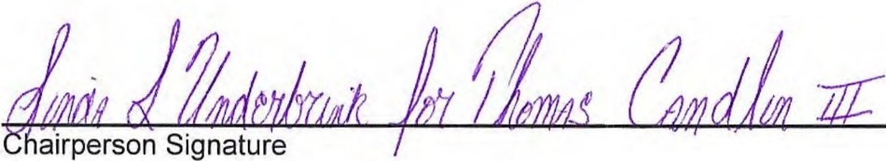
Print Chairperson Name

6-26-19
Signature Date
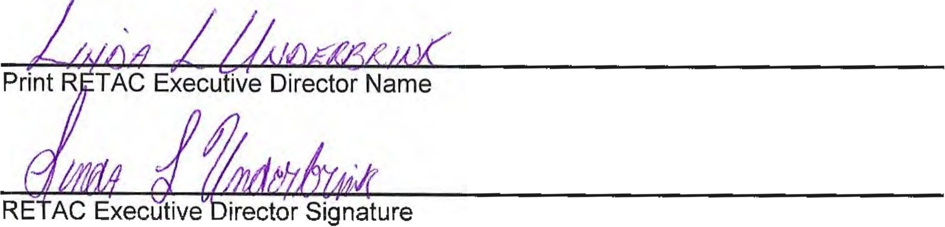

6-26-19
Signature Date

Appendix

Supporting Documents

Attachments

- Foothills RETAC Board of Directors
- EMS Agencies
- Trauma Centers
- Fire Agencies
- Search and Rescue Agencies

Attachment A

Foothills RETAC Board of Directors

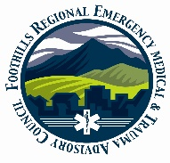 Foothills Regional Emergency Medical & Trauma Advisory Council
(FRETAC) Serving Boulder, Clear Creek, Gilpin, Grand, & Jefferson Counties

Foothills RETAC
Board of Directors

Boulder Clear Creek County

Jeff Long Open
Alternate Member Member
Boulder Fire Clear Creek EMS

Chris Duran RN Tom Candlin EMT-P (Chair)
Member Member
Longmont United Hospital St. Anthony’s Central

Richard Peebles OEM Pending
Member Member
Boulder County Clear Creek EMS

Deb Hopgood EMT-P Bryan Monseu EMT-P Member Alternate Member
Boulder Community Hospital Clear Creek EMS

Gilpin Grand

Pending Allen Pulliam EMT-P
Member Member
Gilpin County BOCCs Grand County EMS

Brandon Daruna EMT-P Open
Member Member
Gilpin Ambulance

Open Natalie Debakker RN
Member Member
Timberline Fire Denver Health East Grand

Jefferson Executive Director

Jason Roosa MD Linda Underbrink RN
Member
Exempla Lutheran Ned Ctr

Dave Richter MD
Alternate
St. Anthony’s Hospital

William P. Dolan (Treasurer) A-EMT
Member
St Anthony Prehospital Services

Mark Johnson MD
Member
Jefferson County Dept of Health

Attachment B

EMS Transporting Agencies

County | Name of Agency | Ambulances
BOULDER | AMR - Boulder County | 9
BOULDER | Lafayette Fire Department | 2
BOULDER | Longmont Fire Department | 2
BOULDER | Louisville Fire Protection District | 3
BOULDER | Lyons Fire Protection District | 2
BOULDER | Mountain View Fire Protection District | 6
BOULDER | Nederland Fire Protection District | 3
BOULDER | Rocky Mountain Fire District | 2
CLEAR CREEK | Clear Creek Ambulance | 5
GILPIN | Gilpin County Ambulance Auth. | 6
GRAND | Grand County EMS | 9
JEFFERSON | AMR Arvada/Golden | Shared
JEFFERSON | Arvada Fire | 7
JEFFERSON | Coal Creek Canyon Fire | 1
JEFFERSON | Elk Creek FPD | 3
JEFFERSON | Evergreen FPD | 4
JEFFERSON | Flight for Life Ground and Air Transport | 2 Ground  6 Air
JEFFERSON | Highland Rescue Team Ambulance District | 3
JEFFERSON | I-Care Ambulance | 2
JEFFERSON | Indian Hills FPD | 2
JEFFERSON | Inter-Canyon FPD | 3
JEFFERSON | North Fork FPD | 3
JEFFERSON | Stadium Ambulance, Inc.  Shared with MHRETAC | 15
JEFFERSON | West Metro FPD | 18
 | Totals Known | 112

Attachment C

Foothills RETAC Designated Trauma Centers

County | Facility Name | Level
Boulder
 | Avista Hospital | III
 | Good Samaritan Medical Center | II
 | Boulder Community Hospital | II
 | Longmont United Hospital | III
 | Longs Peak Medical Center | III
 | Free-Standing EDs | Rapidly changes
Jefferson
 | Lutheran Medical Center | III
 | St Anthony Hospital | I
 | Free-Standing EDs | Rapidly changes
Grand
 | Denver Health East Grand Medical Center | V
 | Middle Park Medical Center-Granby | IV
 | Middle Park Medical Center-Kremmling | IV

Attachment D

Foothills RETAC Fire Agencies

BOULDER
Allenspark Fire
Big Elk Meadows Fire
Boulder Mountain Fire Authority
Boulder Fire
Boulder Rural
Four Mile Fire
Gold Hill Fire
Hygiene Fire
Indian Peaks Fire
Jamestown Volunteer Fire Department
Lafayette Fire Department
Lefthand FPD
Longmont Fire Department
Louisville Fire Protection District
Lyons Fire Protection District
Mountain View Fire Protection District
Nederland Fire Protection District
Pinewood Springs Fire
Rocky Mountain Fire District
Sugar Loaf Fire Dept
Sunshine Fire Protection District

CLEAR CREEK
Clear Creek Fire Authority
GILPIN
Black Hawk Fire
Central City Fire Department
Timberline Fire
GRAND
East Grand Fire
Granby Fire
Grand Lake Fire Protection District
Hot Sulphur Springs Fire
Lower Blue Fire Department
Kremmling Fire Dept
JEFFERSON
Arvada FPD
Coal Creek FD
Elk Creek FD
Evergreen FD
Fairmount FD
Foothills FPD
Genesee FD
Golden FD
Golden Gate FD
Indian Hills FD
Inter-Canyon FD
Lakeside FD
North Fork FD
Pleasant View FD
W. Metro FPD
Wheat Ridge FD
Westminster Fire

Attachment E

Foothills Search & Rescue & Technical Rescue Agencies

Search and Rescue Teams
County | Agency Name
BOULDER | Rocky Mountain Rescue Group
BOULDER | Eldora Mountain Resort Ski Patrol
Clear Creek, Gilpin, Grand and Jefferson | Alpine Rescue Team (SAR)
GRAND | Grand County SAR
Rescue
County | Agency Name
BOULDER | Boulder Emergency Squad
BOULDER | Longmont Emergency Unit
Swift Water/Ice Rescue
County | Agency Name
Clear Creek, Gilpin, Grand and Jefferson | Arvada FPD
" | Evergreen
" | Golden FD
" | W. Metro FPD
" | Westminster Fire

