Regional Emergency Medical
& Trauma Services
Systems Development Biennial Plan

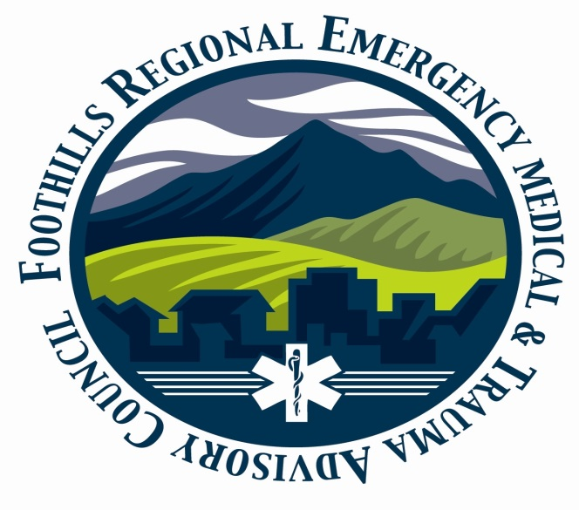

Foothills RETAC
Update for Biennial Plan Cycle
July 1, 2017 – June 30, 2019

Plan: | Update for Plan Cycle
Date Submitted: | 6/26/2018
Contact Person: | Linda Underbrink
Address: | 10127 W Dartmouth Place #201 Lakewood, Co. 80227
Phone: | 303-594-9740

Table of Contents

Section 2: ………………………………………………………………………………………… 36

Accomplishments/Activities FY-18: ………………………………………… 3

Section 4: ………………………………………………………………………………………… 11

New/Updated Goals and Objectives FY-19: ……………………………. 12

Section 5: ………………………………………………………………………………………… 19

Attest Statement: …………………………………………………………………… 0

Appendices: ……………………………………………………………………………………. 21

Supporting Documents for Foothills RETAC (Appendices)

A. Foothills RETAC Board Members: …………………………… 22
B. EMS Transporting Agencies: …………………………………… 25
C. Trauma Centers: ……………………………………………………… 27
D. Fire Agencies: …………………………………………………………. 28
E. Search and Technical Rescue: ………………………………… 30

Section 2: Accomplishments:

FY-16 Goal #1: Injury Prevention

A. Goal Statement

Injuries and deaths in the Foothills RETAC will be decreased throughout the Region through the establishment and utilization of effective cohesive IP programs and strategies.

Injury Prevention

FY-18: Accomplishments/Activities

1st Quarter

- Injury Prevention Activities:
  - ThinkFirst Program: We are now planning a spring update and train the trainer class for ThinkFirst for a refresher on the program. Our ThinkFirst program is always busy with numerous presentations all over the RETAC. We have committed individuals running their programs.
  - Fall-Prevention: We continue to try to coordinate efforts regarding fall prevention. We keep track of classes and offerings to document for the program.

2nd Quarter

- Injury Prevention Activities:
  - ThinkFirst Program: Our ThinkFirst train the trainer class is scheduled for May for a refresher on the program. Our ThinkFirst program is always busy with numerous presentations all over the RETAC. We have committed individuals running their programs.
  - Fall-Prevention: Fingers crossed on our Elderly Fall Prevention Program that we would like to institute depending on grant funding. We continue to try to coordinate efforts regarding fall prevention. We keep track of classes and offerings to document for the program.
3rd Quarter
- Injury Prevention Activities:
  - ThinkFirst Program: Our ThinkFirst train the trainer class is scheduled for May for a refresher on the program. Our new ThinkFirst Director attended training at a conference in New Orleans in April. Our ThinkFirst program is always busy with numerous presentations all over the RETAC. We have committed individuals running their programs.
  - Fall-Prevention: Fingers crossed on our Elderly Fall Prevention Program that we would like to institute depending on grant funding. We continue to try to coordinate efforts regarding fall prevention. We keep track of classes and offerings to document for the program.
4th Quarter and Final Report on Activities and Accomplishments for the Year

- Injury Prevention Activities:
  - ThinkFirst Program: Our ThinkFirst train the trainer class in May went very well and was well-attended by IP Committee members. Much work was also done on designing the goals and objectives for the committee for the next two years. Our ThinkFirst program is always busy with numerous presentations all over the RETAC. We have committed individuals running their programs.
  - Fall-Prevention: Fingers crossed on our Elderly Fall Prevention Program that we would like to institute depending on grant funding. We continue to try to coordinate efforts regarding fall prevention. We keep track of classes and offerings to document for the program.

FY:17-18 Goal #2: Clinical Care

A. Goal Statement

Establish and maintain Foothills RETAC specific Projects and Regional QM Programs and develop processes for these programs.

Clinical Care

FY: 17-18 Accomplishments/Activities

1st Quarter

- Clinical Care
  - Spinal Immobilization study: We have now submitted our second draft of our research paper to the “Prehospital Emergency Care Journal.” We await the review of the paper.
  - This committee oversees all things related to RMD, Data, and EMTS education. With the conclusion of our research paper, they are now considering additional projects and education. A Handtevy System may be offered next fiscal year. A proposal for the Handtevy education should be prevented this month or January after receiving all of the figures we need.

2nd Quarter

- Clinical Care
  - Spinal Immobilization study: Complete and published in the “Journal of Prehospital Emergency Care.” We are so excited to see this completed! It’s been a five-year project in our RETAC with amazing cooperation between facilities, Docs, EMS, and the RETAC. This is one of the things that RETACs are all about!
  - This committee oversees all things related to RMD, Data, and EMTS education. With the conclusion of our research paper, we move on to new projects such as the Handtevy System that will be offered next fiscal year.
  - We are taking a look at the RETAC Trauma Triage Algorithm. Not at all sure it will change until we see how things go with the Chapter Two and Four Task forces, but it’s on our radar.
  - We are planning our biennial Physician Dinner meeting right now. It is tentatively scheduled to be April 4th. This is where we keep up with our facility Docs, Trauma Directors, EMS agency Directors and our board. It’s a great time to hear what they suggest and show off a bit as to what we’ve accomplished.

3rd Quarter

- Clinical Care
  - Spinal Immobilization study: Complete and published in the “Journal of Prehospital Emergency Care.” A presentation was given to SEMTAC in April. We really hope this will act as an incentive and inform the public as to what RETACs do and can do.
  - This committee oversees all things related to RMD, Data, and EMTS education. With the conclusion of our research paper, we move on to new projects.
  - We have completed a quick change to our Trauma Triage Algorithm to accommodate our new facility in Boulder.
  - We held our biennial Physician Dinner in April. It was well-attended by our physicians, facilities, and board members. This is where we keep up with our facility Docs, Trauma Directors, EMS agency Directors and our board. It’s a great time to hear what they suggest and show off a bit as to what we’ve accomplished.

4th Quarter and Final Report on Activities and Accomplishments

- Clinical Care
  - Spinal Immobilization study: Complete and published in the “Journal of Prehospital Emergency Care.” A presentation was given to SEMTAC in April. We really hope this will act as an incentive and inform the public as to what RETACs do and can do.
  - We will await the Chapter 2 and 4 Task force work to make major changes to our algorithm.
  - We held our biennial Physician Dinner in April. It was well-attended by our physicians, facilities, and board members. This is where we keep up with our facility Docs, Trauma Directors, EMS agency Directors and our board. It’s a great time to hear what they suggest and show off a bit as to what we’ve accomplished.

FY:17-18 Goal #3: MCI

A. Goal Statement

Prehospital Providers and Healthcare Facilities will provide a standardized cohesive and efficient response to MCI events within the Foothills RETAC

MCI

FY:17-18 Accomplishments/Activities

1st Quarter

- MCI:

- We continue working with our EMS colleagues within the NCR all-hazards region. We are currently working on a new communications template for radios for EMS agencies contacting each other and the facilities
- We continue working with our Healthcare Coalitions as they remap the regions. Many of our members are active in their coalitions, and members of the HCCs are attending our MCI meetings.
- We will continue working with all our MCI and Surge Cache holders. We are currently working to update access to the cache in Boulder. More to come.

2nd Quarter

- MCI:

  - We continue working with our EMS colleagues within the NCR all-hazards region but are re-directing our efforts into MCI planning as a priority. The committee feels that we have strayed a bit into the planning that others are doing and need to concentrate on our original mission of preparing our region for MCIs.
  - We continue working with our Healthcare Coalitions as they remap the regions. Many of our members are active in their coalitions, and members of the HCCs are attending our MCI meetings.
  - More to come.

3rd Quarter

- MCI:

- We continue working with our EMS colleagues within the NCR all-hazards region but are re-directing our efforts into MCI planning as a priority. The committee feels that we have strayed a bit into the planning that others are doing and need to concentrate on our original mission of preparing our region for MCIs.
- We continue working with our Healthcare Coalitions as they remap the regions. Many of our members are active in their coalitions, and members of the HCCs are attending our MCI meetings.
- More to come.

4th Quarter and Final Report on Activities and Accomplishments

- MCI:

- This quarter was spent aligning our goals and objectives with the work of our partners in MCI management. A survey is being developed for prehospital agencies to tell us what they need from this committee.
- The committee held a RAMP presentation for MCI management. Discussion on the use of the program will continue.

Section 4: Revised Goals and Objectives for FY-19

Injury Prevention

Foothills RETAC New Goal #1 FY 19

Goal Statement

Injuries and deaths in the Foothills RETAC will be decreased throughout the Region through the establishment and utilization of effective cohesive IP programs and strategies.

Background

The FRETAC Injury Prevention (IP) Committee is a coalition of our IP Committee members, FRETAC facility representatives, FRETAC agency representatives and various IP organizations offering supportive agendas. The IP Committee goal stated above has been the foundation and motivation of this well-established, active committee for many years.

The inception of the FRETAC ThinkFirst Chapter in 2012 makes this an important addition to the FRETAC IP Committee and supports the goal of reduction in injuries and deaths in our region. Many FRETAC IP activities include ThinkFirst materials and curricula.

As a Committee, we are collectively dedicated to educating the public through the utilization of our proven programs and activities, with the result of a reduction in injuries and deaths within the counties served by FRETAC.

Components Addressed

Injury Prevention, Information Systems, Public Education, and Integration of Health Services.

Project Description

Objective 1:
Use the most current injury data available to assess commonly occurring types and causes of injury and death within the FRETAC region. Data will be used to design FRETAC IP Committee activities and prioritize appropriate programs with consideration for utilizing current programs in place.

Tasks:

    - Gather current injury data from sources such as Co-Hid, Trauma Registry, and C-DOT’s problem identification report to assess causes and types of injury and death before evaluating needs and determining optimal IP Committee fiscal year activities.
    - Analyze regional injury pre-program data to aid in implementing, performing and promoting evidence-based injury and illness prevention programs and activities within the FRETAC.
    - Gather identical end of year injury data from sources such as Co-Hid and C- DOT to assess efficacy of the FRETAC IP Committee’s fiscal year activities.

Objective 2:
All FRETAC IP Committee members and stakeholders will work together in the spirit of collaboration with the common goal of reducing injury and death in our region.

Tasks:
- Continue to grow, develop and optimize utilization of the FRETAC ThinkFirst Chapter. Track all ThinkFirst related activities continuously and report to the national ThinkFirst Foundation headquarters annually.
- Continue to educate IP Committee members on ThinkFirst curricula and updates.
- Work together continuously with all stakeholders to formulate and review an optimal plan for FRETAC IP activities and programs utilizing current data as stated above.
- Track IP Committee activity.

Objective 3:
Support Other Injury Prevention initiatives within our communities.
Tasks:

- Work collaboratively with other injury prevention groups with the common goal of decreasing injury and death within the FRETAC region.
- Track the success of the IP Committee-wide falls prevention campaign based on volume of falls prevention programs delivered and collaborative efforts within the IP Committee.

Clinical Care

Foothills RETAC New Goal #2 FY-19

Goal Statement

Establish and maintain Foothills RETAC specific Projects and Regional QM Programs and develop processes for these programs

Background:

The Foothills RETAC Clinical Care Committee is a dedicated group of individuals representing all disciplines within an EMTS system. They represent healthcare facilities, prehospital agencies, public health, and counties. They are committed to improving patient care through evidence-based medicine.

Components Addressed:

Evaluation, Information Systems, and Clinical Care

Project Description:

Objective 1:
Evaluate and conduct a regional Quality Management (QM) project within the Foothills RETAC Clinical Care Committee

Tasks:
- Analyze geriatric trauma population for other suitable projects to pursue.
- Identify opportunities and barriers to reaching the geriatric trauma population.
- Using evidence-based data, problems identified, and member input, we will pursue other areas for possible research

Objective 2:
Maintain our Regional Medical Direction/Collaboration program with Mile-High RETAC

Tasks:
- Prehospital QM processes MAY differ from other RETAC QM processes. Identify the differences for this specific set of QM issues
- Work with the DMEMSMD group and other Medical Directors within the RETAC to address prehospital QM issues specifically regarding structure, process, collection of data, flow of data, and membership as above.
- Assess methods for data collection and data submission to the state for the EMS agencies within the RETAC. Work to interface with the vendors, the agencies, and the state to address solutions of data quality.
- Develop Prehospital topical QM Measures to assess data.

Objective 3:
Research the possibility of pursuing a regional CARES program

Tasks

- Gather data regarding the number of facilities now participating in the CARES registry
- Gather data on prehospital agencies now participating in the CARES registry
- Identify the scope, cost, willingness, and requirements of instituting a regional CARES program
- Perform a cost-analysis for the program, weighing the benefits/costs
- Pursue instituting a regional registry if plausible

MCI

Foothills RETAC New Goal #3 FY-19

Goal Statement

As a collaborative effort of the stakeholders in MCI management within the Foothills Region, the MCI Committee endeavors to provide a conduit for communication, education, and planning to increase operational capability.

Background:

The Foothills RETAC MCI Committee has set its sights on developing a robust value proposition that better addresses the needs of agencies that fall within its jurisdiction. With an overarching goal of elevating regional MCI care and management we intend to lead the State as an exemplarily point of MCI expertise. With the loss of Bob Marlin, our long-time leader, we have begun to assess every aspect of our current strategy.

Components Addressed

Mass Casualty, education, System Evaluation.

Project Description

Objective 1:
Create MCI Readiness Assessment Toolkit

Tasks:
- Formulate assessment tool that can be utilized to determine individual agency readiness
- Illustrate value of MCI preparedness
- Develop and communicate best practices for MCI management in our region
- Outline practical path to become more MCI aware and prepared
- Take into account the range of exposure of different audiences
- Package above in a toolkit that can either be easily consumed by agencies or presented by MCI committee members

Objective 2:
Establish Lines of Communication with Regional Agencies

Tasks:
- Divide the region geographically and assign agencies to committee members within their region
- Illustrate value of being an MCI minded agency
- Use toolkit to assess agency readiness and establish a path to increase capability
- Aggregate data related to gaps in regional capability to drive educational offerings

Objective 3:
Develop Consumable MCI Curriculums

Tasks:
- Using results from agency assessments, develop curriculums that address common gaps
- Curriculum should be segmented by agency size and location/access to resources (e.g. rural v. suburban, large v. medium v. small/volley)
- Classes should be prepackaged and available for anyone to disseminate
- In addition to being driven by the gap analysis, classes should prepare agencies to participate in a preconceived exercise
- Initial, broad strokes, concept of exercise

Objective 4:
Design and Execute Regional Exercise(s)

Tasks:
- This event would be designed to expose flaws in current plans and processes
- Could either be multi-jurisdictional or individualized for specific agencies/regions
- Data should be collected on gaps and utilized to drive the next 2-year cycle which will surround plan development/renovation.

Summary:
These projects set out to accomplish a few macro goals:
- Understanding the current state of MCI preparation, at a granular level
- Developing a grassroots communication with agencies within our jurisdiction, with the purposes of illustrating the value of MCI preparation and how the MCI committee can provide a path to greater capability.
- Teaching and testing basic principles, using the data collected to drive the development of more tailored programs.

We believe that, although all steps must be considered during the next two years, focusing effort on each sequentially will allow for maximum benefit. An important aspect of this process is to remain flexible to more pressing needs as they arise, through the process of evaluation and communication. This should be a living document that reflects any pivots that need to be made through the next two years.

Section 5: Attestation:

Section 5: Attest Statement

ATTEST STATEMENT

Biennial Plan Update

By signing below, the RETAC Chairman and the RETAC Coordinator attest that the information contained in this document, to the best of their knowledge, completely and accurately represents the most current information available to complete the RETAC Biennial plan. The goals and objectives incorporated herein have been reviewed and agreed upon by the RETAC Board of Directors to be included in this document.

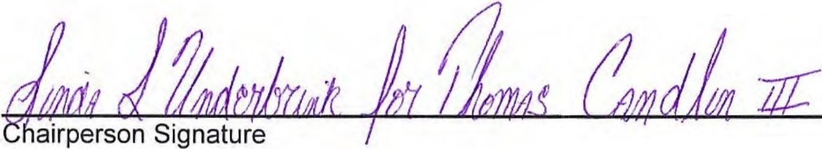
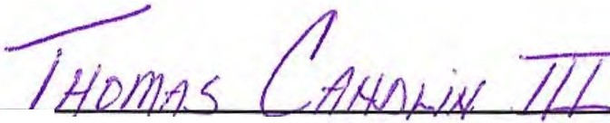
Print Chairperson Name

4- 22 - 11
Signature Date
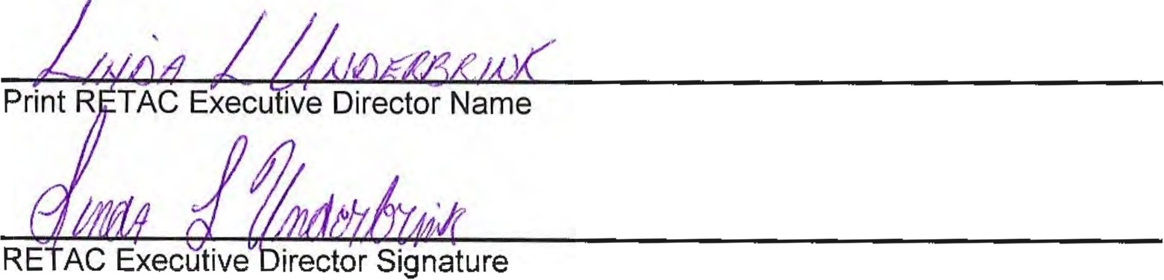

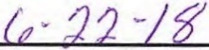

Appendix

Supporting Documents

Attachments

- Foothills RETAC Board of Directors
- EMS Agencies
- Trauma Centers
- Fire Agencies
- Search and Rescue Agencies

Attachment A

Foothills RETAC Board of Directors

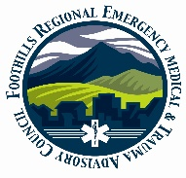 Foothills Regional Emergency Medical & Trauma Advisory Council
(FRETAC) Serving Boulder, Clear Creek, Gilpin, Grand, & Jefferson Counties

Foothills RETAC
Board of Directors

Boulder Clear Creek County

Barb Foster EMT-P Nicolena Johnson EMT-P
Alternate Member Member
Mountain View Fire Clear Creek EMS

Chris Duran RN Tom Candlin EMT-P (Chair)
Member Member
Longmont United Hospital St. Anthony’s Central

Ken Rosales OEM Andrew Bradberry EMT-P
Member Member
Boulder County Clear Creek EMS

Deb Hopgood EMT-P Bryan Monseu EMT-P Member Alternate Member
Boulder Community Hospital Clear Creek EMS

Gilpin Grand

Linda Isenhart Allen Pulliam EMT-P
Member Member
Gilpin County BOCCs Grand County EMS

Brandon Daruna EMT-P Open
Member Member
Gilpin Ambulance

Chip Smith FF Natalie Debakker RN
Member Member
Timberline Fire Denver Health East Grand

Jefferson Executive Director

Jason Roosa MD Linda Underbrink RN
Member
Exempla Lutheran Ned Ctr

Dave Richter MD
Alternate
St. Anthony’s Hospital

William P. Dolan (Treasurer) EMT-I
Member
St Anthony Prehospital Services

Mark Johnson MD
Member
Jefferson County Dept of Health

Attachment B

EMS Transporting Agencies

County | Name of Agency | Ambulances
BOULDER | AMR - Boulder County | 9
BOULDER | Lafayette Fire Department | 2
BOULDER | Longmont Fire Department | 2
BOULDER | Louisville Fire Protection District | 3
BOULDER | Lyons Fire Protection District | 2
BOULDER | Mountain View Fire Protection District | 6
BOULDER | Nederland Fire Protection District | 3
BOULDER | Rocky Mountain Fire District | 2
CLEAR CREEK | Clear Creek Ambulance | 5
GILPIN | Gilpin County Ambulance Auth. | 6
GRAND | Grand County EMS | 9
JEFFERSON | AMR Arvada/Golden | Shared
JEFFERSON | Arvada | 7
JEFFERSON | Coal Creek Canyon Fire | 1
JEFFERSON | Elk Creek FPD | 3
JEFFERSON | Evergreen FPD | 4
JEFFERSON | Flight for Life Ground and Air Transport | 2 Ground  6 Air
JEFFERSON | Highland Rescue Team Ambulance District | 3
JEFFERSON | I-Care Ambulance | 2
JEFFERSON | Indian Hills FPD | 2
JEFFERSON | Inter-Canyon FPD | 3
JEFFERSON | North Fork FPD | 3
JEFFERSON | Stadium Ambulance, Inc.  Shared with MHRETAC | 15
JEFFERSON | West Metro FPD | 18
 | Totals Known | 112

Attachment C

Foothills RETAC Designated Trauma Centers

County | Facility Name | Level
Boulder
 | Avista Hospital | III
 | Good Samaritan Medical Center | II
 | Boulder Community Hospital | II
 | Longmont United Hospital | III
 | Longs Peak Medical Center | III
 | Free-Standing EDs | Rapidly changes
Jefferson
 | Lutheran Medical Center | III
 | St Anthony Hospital | I
 | Free-Standing EDs | Rapidly changes
Grand
 | Denver Health Est Grand Medical Center | V
 | Middle Park Medical Center-Granby | IV
 | Middle Park Medical Center-Kremmling | IV

Attachment D

Foothills RETAC Fire Agencies

BOULDER
Allenspark Fire
Big Elk Meadows Fire
Boulder Mountain Fire Authority
Boulder Fire
Boulder Rural
Four Mile Fire
Gold Hill Fire
Hygiene Fire
Indian Peaks Fire
Jamestown Volunteer Fire Department
Lafayette Fire Department
Lefthand FPD
Longmont Fire Department
Louisville Fire Protection District
Lyons Fire Protection District
Mountain View Fire Protection District
Nederland Fire Protection District
Pinewood Springs Fire
Rocky Mountain Fire District
Sugar Loaf Fire Dept
Sunshine Fire Protection District

CLEAR CREEK
Clear Creek Fire Authority
GILPIN
Black Hawk Fire
Central City Fire Department
Timberline Fire
GRAND
East Grand Fire
Granby Fire
Grand Lake Fire Protection District
Hot Sulphur Springs Fire
Lower Blue Fire Department
Kremmling Fire Dept
JEFFERSON
Arvada FPD
Coal Creek FD
Elk Creek FD
Evergreen FD
Fairmount FD
Foothills FPD
Genesee FD
Golden FD
Golden Gate FD
Indian Hills FD
Inter-Canyon FD
Lakeside FD
North Fork FD
Pleasant View FD
W. Metro FPD
Wheat Ridge FD
Westminster Fire

Attachment E

Foothills Search & Rescue & Technical Rescue Agencies

Search and Rescue Teams
County | Agency Name
BOULDER | Rocky Mountain Rescue Group
BOULDER | Eldora Mountain Resort Ski Patrol
Clear Creek, Gilpin, Grand and Jefferson | Alpine Rescue Team (SAR)
GRAND | Grand County SAR
Rescue
County | Agency Name
BOULDER | Boulder Emergency Squad
BOULDER | Longmont Emergency Unit
Swift Water/Ice Rescue
County | Agency Name
Clear Creek, Gilpin, Grand and Jefferson | Arvada FPD
" | Evergreen
" | Golden FD
" | W. Metro FPD
" | Westminster Fire

