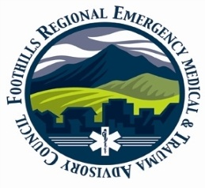
Agency: _______________________________________________
Date: _______________________________________________
Alarm/PCR#: _________________________________________
Location: ____________________________________________
Patient Name: ________________________________________

Fall Hazards Observed:
□ Type/Issue: _______________________________________
□ Type/Issue: _______________________________________

Other Home Safety Issue: Please check
□ Living/Environmental
□ Understanding of Medical Condition and Medical Needs
□ Caregiver/Homecare

Other Home Care Issues not listed:
□ Issue: (Please describe): ___________________________________
□ Issue: (Please describe): ___________________________________

Additional Comments/Clarifications:
__________________________________________________________
__________________________________________________________

Written Follow-up materials left at residence?
□ Yes □ No

Type: _____________________________________________________

Patient agreeable to exploring referral options:
□ Yes □ No □ Patient Unable to agree due to medical condition

Person completing form:

Name: ____________________________Contact: _____________________________

- If Patient is transported: Please present NCR ORIGINAL to Receiving Facility and turn in NCR Copy
To your Agency Administration
- If Patient is NOT Transported: Please turn in the NCR Original & Copy to your Agency Administration

Patient Transported to:
Hospital/Medical Facility: _____________________________________

Patient NOT transported:
EMS Agency Referral To: ___________________________________________
Date: ___________________________________________

